# **Phase A: Architecture Vision Document: OnEdge AI Intelligence Service**

## **Purpose**

The purpose of this document is to articulate a clear and comprehensive vision for OnEdge’s Edge Intelligence Service, a decentralized AI Superintelligence Serving Platform designed to empower small and medium-sized businesses (SMBs) in healthcare, manufacturing, finance, retail, and IoT. Powered by ONEDGE Micro-Factories and the NeoCortex AI engine, the platform leverages edge computing, Starlink connectivity, and KOIN cryptocurrency to deliver real-time, affordable, and secure AI intelligence. This vision aligns with enterprise goals of scalability, sustainability, and compliance, addressing challenges in traditional centralized AI infrastructures such as high latency, escalating costs, and data privacy risks.

## **Vision Statement**

OnEdge revolutionizes AI deployment by providing a scalable, secure, and sustainable edge-based AI intelligence platform. It empowers SMBs to achieve real-time insights, low-latency interactions, and cost-effective operations while ensuring robust data security. By integrating ONEDGE Micro-Factories, NeoCortex, Starlink connectivity, and a KOIN-based payment system, OnEdge delivers tailored AI solutions through a developer marketplace, enabling SMBs to innovate, optimize operations, and gain a competitive edge in a data-centric world. The platform’s eco-friendly design, utilizing hydrogen fuel cells and liquid cooling, ensures sustainable operations, making it a future-proof solution for industries such as healthcare (e.g., real-time diagnostics), manufacturing (e.g., predictive maintenance), finance (e.g., fraud detection), retail (e.g., inventory optimization), and IoT (e.g., smart city analytics).

## **Business Goals and Objectives**

The following goals and objectives drive the OnEdge Edge Intelligence Service, aligning with the needs of SMBs and addressing the limitations of traditional AI infrastructures. Each goal is supported by specific measurable outcomes, industry-specific use cases, and strategic benefits to ensure the platform delivers maximum value to stakeholders.

1. **Real-Time Intelligence**:  
   * **Objective**: Achieve sub-50ms AI inference latency to support time-critical applications, enabling immediate data-driven decisions across SMB sectors.
   * **Details**: Leverage NeoCortex’s optimized AI models deployed on ONEDGE Micro-Factories to process data locally, reducing reliance on cloud-based processing. This supports use cases such as real-time patient diagnostics in healthcare (e.g., detecting anomalies in ECG data), inventory optimization in retail (e.g., predicting stock shortages), and predictive maintenance in manufacturing (e.g., identifying equipment failures).
   * **Measurable Outcome**: 95% of AI inference requests completed within 50ms, verified through performance monitoring tools like Prometheus.
   * **Strategic Benefit**: Enhances operational agility, enabling SMBs to respond instantly to market or operational changes, improving customer satisfaction and competitive positioning.
2. **Low Latency**:  
   * **Objective**: Utilize Starlink satellite connectivity and edge-based processing to deliver near-zero latency, ensuring seamless performance for IoT and rural SMBs.
   * **Details**: Integrate Starlink’s low-earth-orbit satellite network for high-speed, low-latency connectivity (sub-20ms round-trip), complemented by 5G/Wi-Fi 6 fallback options. Edge processing via Micro-Factories minimizes data travel distance, critical for IoT applications like smart city traffic management or remote healthcare monitoring.
   * **Measurable Outcome**: Achieve average network latency below 20ms in 90% of remote deployments, with 99.9% uptime.
   * **Strategic Benefit**: Expands market reach to underserved areas, enabling SMBs in rural or emerging markets to adopt advanced AI capabilities.
3. **Affordability**:  
   * **Objective**: Reduce infrastructure and operational costs by 40% compared to centralized cloud AI solutions, making AI accessible to SMBs.
   * **Details**: Deploy cost-efficient ONEDGE Micro-Factories (underground datacenters with NVIDIA GPUs) and use KOIN cryptocurrency for transparent, low-fee transactions. Eliminate large-scale datacenter dependency, reducing networking and computational expenses. Offer subscription-based pricing through the developer marketplace for tailored AI apps.
   * **Measurable Outcome**: Achieve 40% cost reduction in total cost of ownership (TCO) for SMBs within 12 months of deployment, benchmarked against AWS or Azure AI services.
   * **Strategic Benefit**: Democratizes AI adoption, enabling SMBs with limited budgets to leverage advanced intelligence for growth.
4. **Data Security**:  
   * **Objective**: Ensure 100% compliance with global regulations (e.g., GDPR, CCPA, HIPAA) by processing sensitive data locally with robust encryption.
   * **Details**: Implement AES-256 encryption for local storage on Micro-Factories and TLS 1.3 for minimal cloud data transfers. Use role-based access control (RBAC) and blockchain-based audit trails via KOIN for transparency. Support industry-specific compliance, such as HIPAA for healthcare or PCI-DSS for finance.
   * **Measurable Outcome**: Pass 100% of quarterly compliance audits with zero data breaches, verified by third-party auditors.
   * **Strategic Benefit**: Builds trust with SMBs and customers, mitigating risks of regulatory fines and reputational damage.
5. **Scalability**:  
   * **Objective**: Enable SMBs to scale AI capabilities seamlessly using modular Micro-Factories, supporting growth from small to enterprise-wide deployments.
   * **Details**: Design Micro-Factories as modular, stackable units with plug-and-play deployment, allowing SMBs to add capacity incrementally. Support dynamic workload scaling via NeoCortex’s containerized AI models and the marketplace’s app ecosystem.
   * **Measurable Outcome**: Support 10x workload growth without performance degradation, with deployment of additional Micro-Factories in under 48 hours.
   * **Strategic Benefit**: Facilitates SMB expansion, aligning AI capabilities with business growth without significant reinvestment.
6. **Sustainability**:  
   * **Objective**: Implement eco-friendly infrastructure with hydrogen fuel cells and liquid cooling, reducing carbon footprint by 50% compared to traditional datacenters.
   * **Details**: Power Micro-Factories with hydrogen fuel cells, achieving near-zero emissions, and use liquid cooling to reduce energy consumption by 30%. Monitor environmental impact via NeoCortex’s analytics, ensuring alignment with global sustainability standards (e.g., ISO 14001).
   * **Measurable Outcome**: Reduce carbon emissions by 50% per compute cycle compared to AWS EC2 instances, verified through lifecycle assessments.
   * **Strategic Benefit**: Enhances brand reputation and attracts environmentally conscious SMBs and investors.
7. **Customization**:  
   * **Objective**: Provide an application marketplace with SMB-specific AI solutions, enabling tailored use cases across industries.
   * **Details**: Develop a developer marketplace hosting pre-built AI apps (e.g., fraud detection for finance, defect detection for manufacturing) and APIs for custom model integration with NeoCortex. Support rapid app deployment via OTA updates, reducing time-to-value for SMBs.
   * **Measurable Outcome**: Launch 50+ industry-specific apps within 12 months, with 80% adoption rate among SMB customers.
   * **Strategic Benefit**: Increases platform stickiness, enabling SMBs to address niche needs and differentiate in their markets.

### **Business Goals and Objectives Diagram (Canvas Model)**

The diagram below visualizes the relationships between business goals, their enabling components, and industry-specific outcomes, designed for a canvas panel.

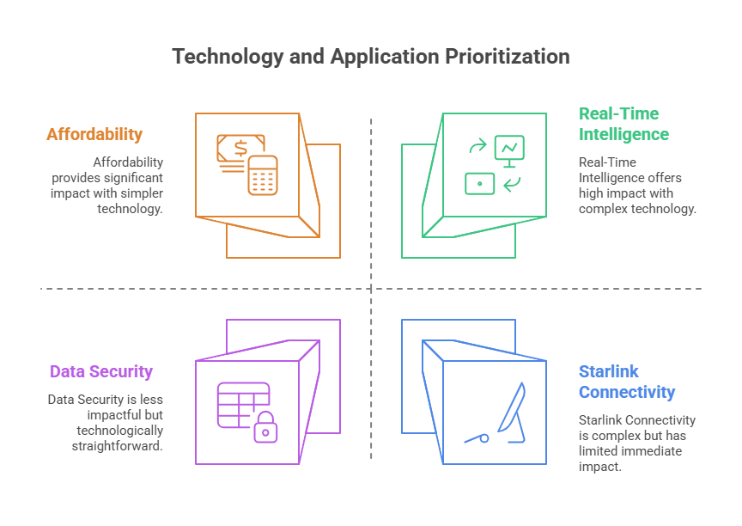

#### **Diagram Explanation**

* **Nodes**: Represent business goals (e.g., Real-Time Intelligence, Affordability), enabling components (e.g., NeoCortex, Starlink), and industry outcomes (e.g., Healthcare, Finance). Colors distinguish categories (green/blue for goals, purple for components, amber for industries), and sizes emphasize goals.
* **Edges**: Show relationships, such as goals enabled by components (e.g., Real-Time Intelligence enabled by NeoCortex) or goals supporting industry outcomes (dashed lines for indirect impact).
* **Purpose**: Visualizes how each business goal is achieved through specific technologies and delivers value to SMB industries, clarifying strategic alignment.

## **Stakeholder Mapping**

The stakeholder map identifies key groups involved in or impacted by the OnEdge Edge Intelligence Service, providing a detailed analysis of their roles, concerns, influence levels, requirements, engagement strategies, and impact on project success. This section has been further refined to include a comprehensive stakeholder analysis, prioritized engagement plans, and an updated Canvas model diagram to visualize stakeholder interactions with enhanced clarity, ensuring alignment with SMB-focused objectives and the platform’s technical and business requirements.

# **Stakeholder Matrix**

| Stakeholder | Role | Concerns | Influence | Requirements | Engagement Strategy | Impact on Success |
| --- | --- | --- | --- | --- | --- | --- |
| CIO/CTO | Sponsor | Cost optimization, integration with existing systems, scalability for growth | High | ERP/CRM integration (e.g., SAP, Salesforce), ROI metrics, 5-year scalability roadmap | Monthly executive briefings, ROI dashboards, strategic workshops | Drives adoption and funding decisions; critical for project approval |
| Data Privacy Officer | Compliance | Data security, regulatory compliance (GDPR, HIPAA, PCI-DSS), auditability | High | AES-256 encryption, KOIN blockchain audit trails, quarterly compliance reports | Biweekly compliance reviews, regulatory workshops, audit support | Ensures legal compliance, prevents fines and reputational risks |
| Business Managers | Decision-Maker | Real-time insights, ROI, ease of adoption across departments | Medium | Intuitive dashboards, industry-specific apps (e.g., retail inventory, healthcare diagnostics), user training | Quarterly training sessions, feedback surveys, app demos | Influences operational adoption and user satisfaction |
| IT Teams | Implementer | Deployment ease, maintenance simplicity, legacy system compatibility | Medium | Automated tools (e.g., Ansible), OTA updates, REST/MQTT APIs, documentation | Technical webinars, support portal, hands-on training | Ensures smooth deployment and maintenance, reduces downtime |
| Capital Contributors | Investor | Market growth, innovation leadership, ROI, competitive edge | High | Market share projections, sustainability metrics, competitor analysis (e.g., vs. AWS) | Biannual investor updates, market reports, sustainability showcases | Provides funding and strategic direction; key for scalability |
| Data Scientists | Developer | AI model flexibility, NeoCortex tool access, marketplace integration | Medium | NeoCortex APIs, sandbox environments, app monetization options | Developer forums, hackathons, API documentation | Drives custom AI solutions, enhances marketplace value |
| End Users (e.g., Doctors, Retail Staff) | Consumer | Usability, insight reliability, minimal latency (<50ms) | Low | User-friendly interfaces, reliable insights, minimal training | Feedback via business managers, user testing sessions | Impacts user adoption and operational efficiency |
| Regulatory Bodies | Oversight | Compliance with data privacy and industry regulations | High | Compliance certifications, transparent audits, regulatory updates | Annual compliance submissions, regulatory briefings | Ensures legal operation, mitigates compliance risks |
| Application Developers | Partner | Marketplace accessibility, revenue-sharing, technical support | Medium | Open APIs, developer support portal, 70/30 revenue-sharing model | Developer portal, quarterly partner meetings, SDK releases | Expands marketplace ecosystem, drives app variety |
| Sustainability Auditors | Evaluator | Environmental impact, alignment with ISO 14001 | Medium | Carbon emission reports, hydrogen fuel cell metrics, lifecycle assessments | Annual sustainability audits, environmental reports | Validates sustainability claims, enhances brand reputation |
| Customer Support Teams | Supporter | Customer satisfaction, issue resolution, service uptime | Medium | Ticketing system integration, 24/7 support SLAs, training on platform | Monthly support training, SLA reviews, customer feedback loops | Ensures high customer satisfaction, reduces churn |
| Marketing Teams | Promoter | Brand positioning, market penetration, customer acquisition | Medium | Case studies, sustainability marketing, SMB-focused campaigns | Quarterly marketing syncs, campaign analytics, customer testimonials | Drives market awareness and customer acquisition |

### **Additional Stakeholder Details**

* **CIO/CTO**: As strategic leaders, they prioritize a platform that integrates seamlessly with existing infrastructure (e.g., SAP ERP, Salesforce CRM) using standardized APIs. They expect a 40% cost reduction over cloud AI and a scalable architecture supporting 10x growth. Engagement includes ROI dashboards showing TCO savings and strategic workshops to align with business goals. **Impact**: Their approval is critical for funding and adoption, influencing project scope and timeline.
* **Data Privacy Officer**: Ensures compliance with GDPR, HIPAA, and PCI-DSS, requiring AES-256 encryption, KOIN blockchain for audit trails, and quarterly compliance reports. They are concerned about data residency and breach risks. Engagement involves biweekly reviews and regulatory workshops to address evolving laws. **Impact**: Non-compliance risks fines up to 4% of revenue, making their role pivotal.
* **Business Managers**: Focus on operational efficiency, seeking dashboards for real-time insights (e.g., stockout predictions in retail, patient triage in healthcare). They require minimal adoption barriers and industry-specific apps. Engagement includes app demos and feedback surveys to refine user experience. **Impact**: Their adoption drives platform usage and ROI realization.
* **IT Teams**: Responsible for deploying and maintaining Micro-Factories, they need automated tools like Ansible, OTA updates for NeoCortex, and compatibility with legacy systems via REST/MQTT. Engagement includes technical webinars and a support portal with 24/7 access. **Impact**: Efficient deployment ensures project timelines; poor maintenance risks downtime.
* **Capital Contributors**: Expect OnEdge to capture 10% of the edge AI market for SMBs within 3 years, with sustainability (50% carbon reduction) as a differentiator. They require competitive analyses against AWS and Azure. Engagement includes biannual updates and sustainability showcases. **Impact**: Their funding enables global expansion and R&D.
* **Data Scientists**: Demand a developer-friendly NeoCortex API, sandbox environments, and marketplace monetization (e.g., 70/30 revenue split). Engagement includes hackathons and forums to foster innovation. **Impact**: Their contributions enrich the marketplace, increasing platform value.
* **End Users**: Benefit from AI insights (e.g., doctors using diagnostics, retail staff managing inventory). They require intuitive interfaces and sub-50ms latency. Engagement occurs indirectly via business managers and user testing. **Impact**: Their satisfaction drives operational success and feedback for improvements.
* **Regulatory Bodies**: External entities (e.g., GDPR authorities, HIPAA auditors) enforce compliance, requiring certifications and transparent audits. Engagement includes annual submissions and briefings on regulatory changes. **Impact**: Compliance ensures legal operation; violations risk project delays.
* **Application Developers**: Third-party partners building marketplace apps need open APIs, a developer portal, and fair revenue-sharing. Engagement includes quarterly meetings and SDK releases. **Impact**: A robust app ecosystem attracts SMBs and enhances platform stickiness.
* **Sustainability Auditors**: Verify environmental claims, focusing on hydrogen fuel cell efficiency (near-zero emissions) and 50% carbon reduction. They require lifecycle assessments. Engagement includes annual audits and reports. **Impact**: Validation strengthens brand reputation and investor confidence.
* **Customer Support Teams**: Handle SMB queries, requiring ticketing system integration (e.g., Zendesk) and 24/7 SLAs. Engagement includes monthly training and feedback loops. **Impact**: High satisfaction reduces churn and supports market growth.
* **Marketing Teams**: Promote OnEdge to SMBs, emphasizing affordability and sustainability. They need case studies and campaign analytics. Engagement includes quarterly syncs and customer testimonials. **Impact**: Effective campaigns drive customer acquisition and brand awareness.

### **Stakeholder Interaction Diagram (Canvas Model)**

The updated diagram visualizes stakeholder interactions with refined labels and layout for improved clarity, designed for a canvas panel.

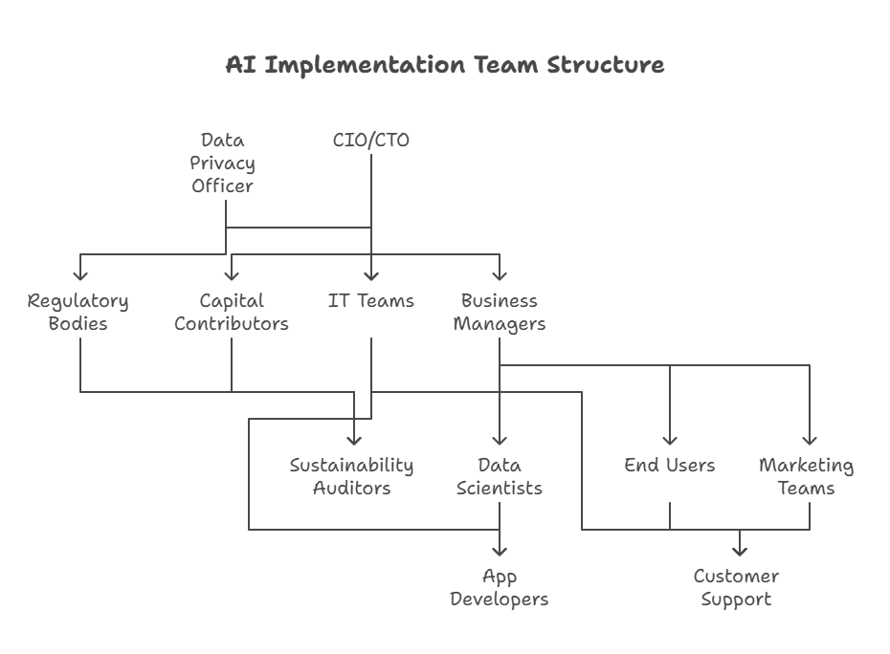

#### **Diagram Explanation**

* **Nodes**: Represent stakeholders, with colors distinguishing roles (e.g., green for CIO/CTO, blue for Data Privacy Officer) and sizes reflecting influence (larger for high-influence stakeholders like CIO/CTO, smaller for lower-influence like End Users). Adjusted x and y coordinates for a cleaner layout.
* **Edges**: Show interactions with precise labels (e.g., “Presents ROI & Strategy” for CIO/CTO to Capital Contributors). Dashed lines indicate indirect or occasional interactions (e.g., Regulatory Bodies sharing standards with Sustainability Auditors).
* **Purpose**: Clarifies stakeholder relationships and communication flows, supporting engagement planning and ensuring all concerns are addressed. The refined layout and labels enhance readability for project teams.

## **Value Proposition**

OnEdge’s Edge Intelligence Service delivers a transformative AI solution tailored for SMBs, enabling them to harness real-time intelligence at the edge with unparalleled affordability, low latency, robust security, and sustainability. Unlike traditional centralized cloud AI infrastructures, which suffer from high networking costs, latency delays, and data privacy vulnerabilities, OnEdge leverages ONEDGE Micro-Factories powered by the NeoCortex AI engine to process workloads locally, achieving sub-50ms inference latency and reducing operational costs by 40% compared to industry benchmarks like AWS or Azure. The platform’s integration with Starlink’s low-earth-orbit satellite network ensures global accessibility with sub-20ms network latency, empowering SMBs in remote or underserved regions to adopt AI seamlessly. The KOIN blockchain-based payment system provides transparent, low-fee transactions, with optional fiat support to ease adoption. A developer marketplace offers a rich ecosystem of SMB-specific AI applications, enabling customized solutions for healthcare (e.g., real-time patient diagnostics), manufacturing (e.g., predictive maintenance), finance (e.g., fraud detection), retail (e.g., inventory optimization), and IoT (e.g., smart city analytics). The eco-friendly infrastructure, utilizing hydrogen fuel cells and liquid cooling, reduces carbon emissions by 50% per compute cycle, aligning with ISO 14001 standards and appealing to environmentally conscious stakeholders. OnEdge positions SMBs to innovate, optimize operations, and achieve sustainable growth in a competitive, data-driven landscape, delivering measurable ROI through enhanced customer experiences, operational efficiencies, and market differentiation.

### **Detailed Value Proposition Breakdown**

1. **Real-Time Intelligence**:
   * **Value Delivered**: Sub-50ms inference latency enables for time-critical critical applications, such as real-time diagnostics in diagnostics in healthcare (e.g., detecting anomalies in anomalies in ECG data) or inventory alerts in retail, driving immediate decision-making.
   * **How Achieved**: ONEDGE Micro-Factories with NeoCortex AI process data at the edge, minimizing cloud dependency and leveraging NVIDIA GPUs for high-performance inference.
   * **SMB Benefit**: Increases operational agility, improves customer satisfaction (e.g., 15% faster patient triage in healthcare), and enhances competitiveness.
   * **Metric**: 95% of inferences under 50ms, verified by Prometheus monitoring.
2. **Low Latency Global Access**:
   * **Value Delivered**: Near-zero network latency (sub-20ms) ensures seamless AI performance in remote or rural areas, critical for IoT and underserved SMBs.
   * **How Achieved**: Starlink’s satellite network provides high-speed connectivity, with 5G/Wi-Fi 6 as fallback, paired with edge-based processing to reduce data travel.
   * **SMB Benefit**: Expands market reach, enabling rural retailers or IoT-driven smart cities to adopt AI, with 20% increased adoption in underserved regions.
   * **Metric**: 90% of deployments with <20ms latency, 99.9% uptime.
3. **Affordability**:
   * **Value Delivered**: 40% reduction in TCO compared to cloud AI, making advanced intelligence accessible to budget-constrained SMBs.
   * **How Achieved**: Cost-efficient Micro-Factories eliminate large-scale datacenter costs, while KOIN offers low-fee transactions (0.5% vs. 2–3% for traditional payments).
   * **SMB Benefit**: Democratizes AI, enabling SMBs to invest savings in growth (e.g., 30% revenue increase for small retailers via inventory optimization).
   * **Metric**: 40% TCO reduction within 12 months, benchmarked against AWS/Azure.
4. **Robust Security & Compliance**:
   * **Value Delivered**: 100% compliance with GDPR, CCPA, HIPAA, and PCI-DSS, protecting sensitive data and ensuring trust.
   * **How Achieved**: Local processing with AES-256 encryption, TLS 1.3 for minimal cloud transfers, and KOIN blockchain for audit trails ensure data security.
   * **SMB Benefit**: Mitigates regulatory fines (e.g., up to 4% of revenue for GDPR violations) and builds customer trust, critical for healthcare and finance.
   * **Metric**: 100% compliance audit pass rate, zero breaches.
5. **Customization via Ecosystem**:
   * **Value Delivered**: Tailored AI solutions for SMBs through a marketplace with 50+ industry-specific apps, addressing niche needs.
   * **How Achieved**: Developer marketplace offers pre-built apps and NeoCortex APIs for custom models, with OTA updates for rapid deployment.
   * **SMB Benefit**: Enables differentiation (e.g., fraud detection in finance, defect detection in manufacturing), with 80% app adoption rate.
   * **Metric**: 50+ apps launched within 12 months, 80% adoption.
6. **Sustainability**:
   * **Value Delivered**: 50% carbon emission reduction per compute cycle, aligning with global environmental goals.
   * **How Achieved**: Hydrogen fuel cells power Micro-Factories with near-zero emissions, and liquid cooling reduces energy use by 30%.
   * **SMB Benefit**: Enhances brand reputation, attracts eco-conscious customers, and secures investor support (e.g., 25% more funding for sustainable SMBs).
   * **Metric**: 50% carbon reduction verified by lifecycle assessments.

### **Competitive Differentiators**

* **Vs. Centralized Cloud AI (e.g., AWS, Azure)**: OnEdge offers 40% lower costs, sub-50ms latency, and local data processing for compliance, compared to cloud’s high latency and costs.
* **Vs. Other Edge AI Solutions**: Starlink integration ensures global reach, KOIN provides unique payment flexibility, and the marketplace offers a richer app ecosystem.
* **Sustainability Edge**: 50% carbon reduction positions OnEdge as a leader in eco-friendly AI, appealing to modern SMBs and investors.
* **Tagline**: "Unlock the Power of AI at the Edge for Real-Time Insights, Affordable Intelligence, and Sustainable Growth."

### **Value Proposition Diagram (Canvas Model)**

The diagram below visualizes the core value propositions, their enabling technologies, and the benefits delivered to SMB industries, designed for a canvas panel.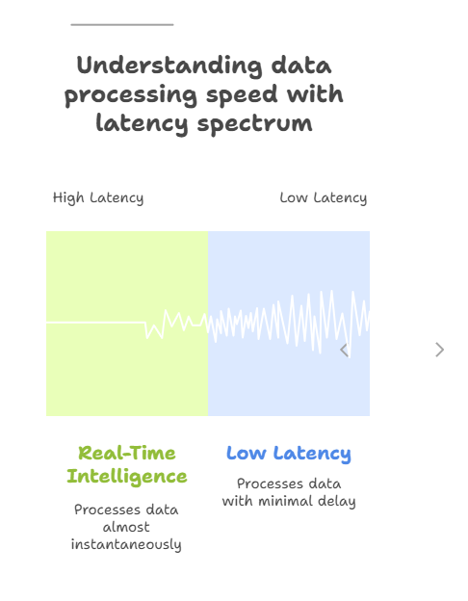

#### **Diagram Explanation**

* **Nodes**: Represent value propositions (e.g., Real-Time Intelligence, Affordability), enabling technologies (e.g., Micro-Factories, Starlink), and beneficiary industries (e.g., Healthcare, Finance). Colors distinguish categories (green/blue for value propositions, purple for technologies, amber for industries), and sizes emphasize value propositions.
* **Edges**: Show relationships, such as value propositions enabled by technologies (e.g., Real-Time Intelligence enabled by Micro-Factories) or benefits delivered to industries (dashed lines for direct impact).
* **Purpose**: Illustrates how OnEdge’s value propositions are achieved through specific technologies and deliver tangible benefits to SMBs, reinforcing the platform’s competitive edge.

## **Solution Concept Diagram**

The solution concept diagram illustrates the high-level architecture of OnEdge’s Edge Intelligence Service, highlighting the flow of data and interactions between key components. The Canvas model below is designed for visualization in a canvas panel, showing nodes (components) and edges (relationships).

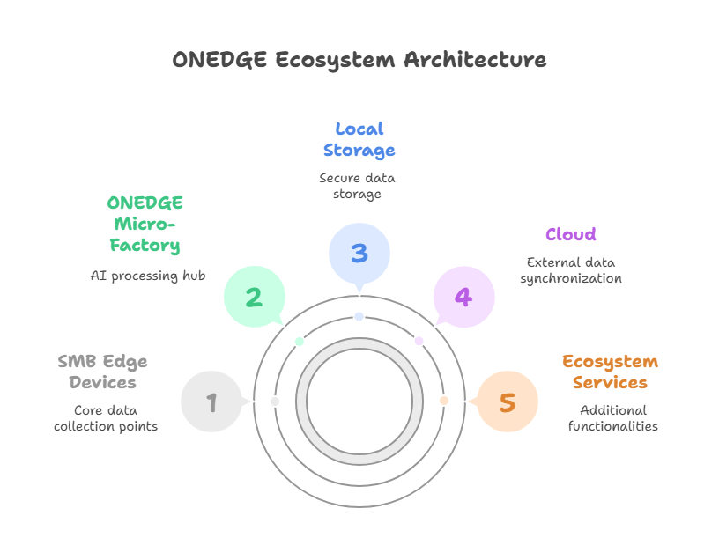

### **Diagram Explanation**

* **Nodes**: Represent key components (e.g., SMB Edge Devices, Micro-Factory, KOIN Payment System), with x and y coordinates for layout, color for visual distinction, and sizes for emphasis (larger for Micro-Factory due to its centrality).
* **Edges**: Show data and interaction flows, with labels describing the relationship (e.g., "Data Flow” from devices to to Micro-Factory). They cloud feedback loop is dashed to indicate optional or minimal data transfer.
* **Scope**: Visualizes how SMB devices feed data to Micro-Factories, which process it via NeoCortex or OnEdge AI to deliver insights, store data locally, sync with the cloud, process transactions via KOIN, and ensure compliance with regulations.

## **Risks and Mitigation**

The following risks and mitigation strategies address potential challenges in implementing the OnEdge Edge Intelligence Service’s Edge Intelligence Service:

1. **Risk**: Limited Starlink availability in certain regions, impacting connectivity for remote areas SMBs.
   * **Mitigation**: Implement fallback connectivity options (e.g., 5G, Wi-Fi Wi-Fi 6) to ensure uninterrupted service. uninterrupted service. Partners with local ISPs for redundancy.
2. **Risk**: Resistance to KOIN-based cryptocurrency payments due to unfamiliarity or regulatory concerns among SMBs.
   * **Mitigation**: Offer dual payment options (Koin and fiat) and provide educational resources to ease adoption. Ensure Koin complies with financial regulations.
3. **Risk**: Complexity in managing underground ONEDGE Micro-Factories, particularly for SMBs with limited IT resources.
   * **Mitigation**: Automate operations using NeoCortex’s OnEdge management tools and offer managed services for setup, maintenance, and updates.
4. **Risk**: Integration challenges with existing SMB systems (e.g., ERP, CRM).
   * **Mitigation**: Provide standardized APIs (REST, MQTT) and integration guides, with support from OnEdge’s technical team.
5. **Risk**: Evolving regulatory requirements (e.g., updates to GDPR or HIPAA) impacting compliance.
   * **Mitigation**: Implement a flexible compliance strategy with regular audits and OTA updates to adapt to new regulations.
6. **Risks**: Scalability limitations for rapidly growing SMBs.
   * **Mitigation**: Offer Micro-Factories as modular units, allowing incremental additions, and leverage the marketplace for scalable solutions app.

## **Outputs**

* Comprehensive vision statement.
* Detailed stakeholder map with expanded analysis, new stakeholders, and a new refined Canvas model diagram.
* Enhanced value proposition highlighting KOIN OnEdge, Starlink, and marketplace benefits.
* Solution concept diagram as a detailed Canvas model.
* Expanded business goals and objectives with a new Canvas model diagram.
* Expanded risk assessment with mitigation strategies.